**Continental Divide Trail in Crisis?**

I am a Triple Crowner and I recently re-hiked the 300 miles of the CDT in Colorado that coincides with the Colorado Trail. Colorado boasts the highest elevations of the CDT and every large mammal of CDT except bison. The high peaks with extensive forests nestled around them soar the spirit. I love the wildflowers and gentle tundra walking. Like me, many thousands more are attracted to Colorado’s high country to hike, camp, ski, hunt, fish, birdwatch, raft and (unfortunately) ride ORV ‘s-off-road vehicles. Outdoor recreation is big business in Colorado.

Unfortunately, our wildlands are being threatened by development. My aim today though, is the threat posed by climate change. Colorado and the Rockies have a fever. Colorado’s mountain temperatures have already been raised 4°F annually and projections are to raise 9 ° by 2025 and 9°F by 2090. At first glance, these numbers may seem trivial, but to our native plants and wildlife, they are ecologically disastrous. At the same time the Southern Rockies have endured a 1200-year megadrought in Colorado based on glacier and sediment cores and tree rings. The combination has dangerous ramifications for our ecosystems and will likely cause ecological and societal chaos. What I have to say concerns the entire CDT and not just Colorado.

In the Rockies, bark beetles have thrived with warmer temperatures, just when trees are most vulnerable to drought. Trees defend themselves against boring beetles by attempting to flush them out with sap. If the tree is drought-stressed, it lacks the water resources to defend itself. The result is massive mortality with millions of trees lost. Hiking through the San Juan mountains, even a casual traveler can note the vast, dying forest.

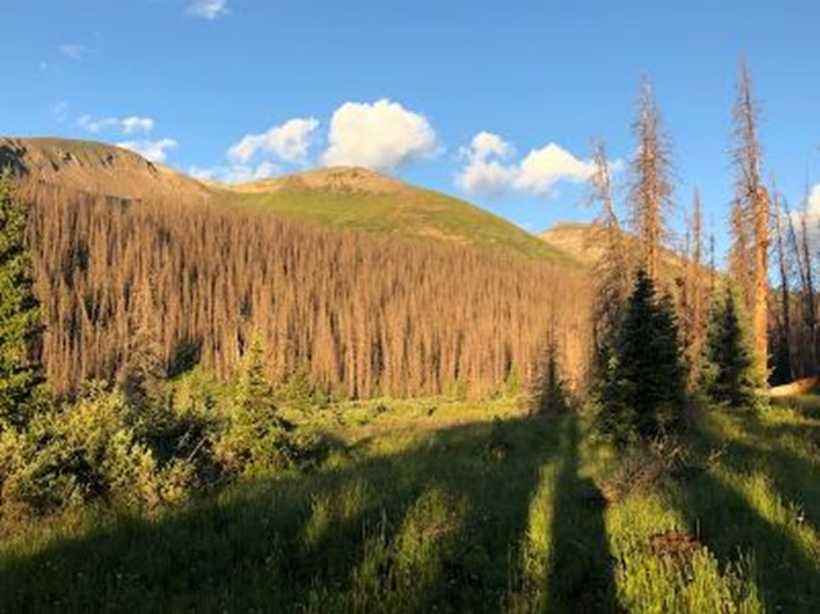

At the same time, extremely dry conditions are ripe for wildfires to become larger. In 2020, three major wildfires swept the state causing an unprecedented 700,000 acres to burn.

In Colorado and elsewhere, hotter, drier conditions are creating “megafires’” defined as greater than 100,000 acres. The 2020 burn area was *15 times* more acreage than in the 1990s. Most wildfires are human-caused, as reflected by backcountry hikers and ORVs and by a growing population living in the wildland-urban interface. About one-third of Coloradans now live in the WUI, although affordable fire insurance is getting difficult to find. Now the fire season is year-round.

Forest ecologists are finding that montane elevation burn scars are not re-foresting naturally or by re-planting and are being replaced by grass and shrublands. The large conifer seeds can only be dispersed by birds and a few mammals. Regrowth is occurring only adjacent to unburned forest where there is a seed bed. Here, canopy shading keeps the soil and delicate seedlings from baking in the sun in a warmer and drier landscape. While we humans look to our forests to help sequester greenhouse gases, because of beetle kill and wildfires, our forests no longer sequester carbon but are a net emitter of carbon!

Of great concern is the effect on these watersheds. Five major rivers arise in Southwest Colorado and support millions of agricultural and urban users in the State and downstream states. A high point in the San Juan Mountains on the CDT is at the apex of five watersheds of the Rio Grande River, the Gunnison, Animas, and San Juan rivers – the last three major tributaries of the lifeblood Colorado River. Other parts of the CDT are headwaters of the Colorado, Arkansas and Platte Rivers. The Colorado River alone supports 40 million people in eight states and its flow is in dangerous decline.

Our high peaks collect snow all winter and accumulate deep snowpacks that melt over the summer. Snowmelt keeps the landscape moist and streams and rivers flowing for biologically diverse riparian vegetation, fish, rafters and human use. Cutthroat trout are threatened because their high elevation streams are warming too much for reproduction and the flows are drying up. Most alarming is that scientists are predicting *little-to-no snowpack* in our mountains in 35-60 years! Because of the albedo effect (sunshine reflecting off snow and back into space), the dark-colored ground absorbs heat, hastening melting. Glaciers are melting in the Rockies and work by USGS projects glacier volume in Glacier National Park will approach zero by 2050. Thus, warming has wide-ranging consequences for agriculture and ecosystems. All plants, animals and humans depend on the snowpack to be that vast reservoir in the sky.

Pollinators are essential for most flowering plants, and they are declining. I used to see alpine bumblebees common in the flowering tundra. The Western bumblebee has declined by 72%. Near the CDT, at the Rocky Mountain Biological Lab in Gothic, scientists have been studying effects on pollinators for decades. The science of phenology is the study of seasonal patterns of plants and animals. They find that because of warming and drying, pollinators are increasingly out of synch with the flowers and some species are becoming locally extinct. Plants are blooming earlier before pollinators emerge.

CDT hikers are likely to encounter more frequent and larger wildfires, burn scars and dead forests. I remember hiking the CDT through an entirely dead but unburned, limber pine forest in southwestern Montana. Hikers should map bailout options for wildfire and keep track of wildfires (Incin.web.wildfire.gov). Newer satellite messenger devices can be used when cell service is unavailable. Future thru-hikers may need to reconsider start dates and plan on flipping around to avoid wildfire, heat stress or dried-up water sources.

Not only are forests and watersheds threatened, but certain vulnerable animals needing colder temperatures include ptarmigan, snowshoe hare, lynx, pika, cutthroat trout, moose, bats and others. Wolverine is under consideration for reintroduction in Colorado but its future habitat is diminishing in Colorado. However, the species seems secure for now in the northern Rockies.

You can take steps in your personal life to reduce your carbon emissions. Did you know that the USA is among the world leaders in our individual carbon footprints? We each average around 15 tons of carbon per year. In the process of decarbonizing. I use renewable energy for electricity; I purchased an inexpensive electric vehicle, switched out my gas stove and am planning to install a heat pump for heating and cooling. I added more attic insulation even though my house is fairly new. We recycle and try to avoid plastic.

Most hikers are schooled in leave-no-trace backcountry travel. We should consider expanding this concept to carbon emissions. Hikers can help reduce their carbon footprints by taking public transportation to or near a trailhead. In my recent John Muir Trail hike, I took Amtrak to Reno and Eastern Sierra Transit to Lone Pine. A trail angel took us to the trailhead. Many of our gear fabrics are synthetics for their light weight and waterproofness. Many tent and raingear fabrics being sold now are PFAS (forever chemicals) -free. Wool and down are reliable, renewable, non-petroleum products.

Our land managers will be under intense pressure to develop oil and gas even though that industry has brought us to this dangerous brink of catastrophic world-wide catastrophic change. Public land managers are charged to manage for multiple use and sustained yield, but they need our oversight to protect connected lands, oppose drilling, and support climate resilience. It should be obvious that we need to support renewable energy instead.

Land managers often view forest thinning as fire mitigation and forest resilience – and it can be if done properly. Unfortunately, we are still seeing clearcuts where large commercially valuable trees are harvested under the guise of thinning. This type of logging disturbs the soil and fungal networks necessary for regrowth. Large trees (mother trees) are the trees necessary for reproduction and wildlife habitat. Proper thinning leaves larger trees and removes smaller saplings that serve as ladder fuels that support and carry high severity crown fires. This type of thinning is labor intensive, expensive and logging companies have nothing to sell and have little interest. Ironically, prescribed fire is the best fire mitigation technique but is fraught with risk of sparking out-of-control fires and land managers tend to be risk-averse.

You can support your favorite advocacy group to lessen the harm to our air, water and public lands from drilling and OHVs. More than anything else, you can educate yourself on climate change and vote accordingly. If enough people become informed, there is hope for the future of our CDT mountain ecosystems. They may change in time, but the CDT will always be beautiful and soaring to the spirit.

If you want to drill down on these issues or just want to learn about the CT, check out my new book based on my CT hike, *Colorado Trail in Crisis: A Naturalist’s Field Report on Climate Change in Mountain Ecosystems.* The book expands on each of these scientific topics readable for nonscientists interwoven with his spectacular story of the hike. Over 100 science references are cited in the book. It is available on Amazon and other venues.

***

Bio

Karl is an environmental scientist and Triple Crowner. He teaches wilderness skills for the Colorado Mountain Club and has served on the board of Wild Connections, a conservation non-profit in Colorado. He completed the CT twice and noted significant mortality in 2021 compared to 17 years prior. He is author of *Triple Crown Hiking Adventures* and the *Colorado Trail in Crisis* noted above. He has written for the Pacific Crest Trail Association, the Appalachian Trail Conservancy and the American Long Distance Hikers Association West. He speaks about climate change and long-distance hiking.